**“Develop a new manufacturing approaches for production of microcircuitry by 3D laser patterning”**

**By**

**Yibing Liu**

**An Honors report submitted for the Degree of:**

**BEng in Electrical and Electronic Engineering**

**Supervisor: Dr. Jose Marques Hueso**

**April 2020**

I. Synopsis

With the continuous upgrading of technology, electronic devices are becoming smaller and more precise. For different electronic equipment, personalized electronic devices and circuit layout are particularly important. In the research the professor has done, a method for selective plating of 2D microcircuity on polyetherimide[1] is proposed. By reproducing the existing technology, it is possible to develop a new method in selecting plating. The core task of the project is to use high-power lasers to replace the LEDs in the existing technology in the exposure process.

The whole project is divided into two parts. Firstly, use existing equipment to design a system that can basically reproduce the process in the paper given by the professor, following the method provided on the thesis, carved the desired mark on the polyetherimide film, which simulate the process of engraving microcircuitry on a 2D surface. Because the wavelength of the laser can influence the result of exposure, it is also useful to design a system to change the wavelength of the laser. However, limited by the lack of equipment, the aim of changing the wavelength is cancelled in the second semester.

In the second part, to achieve 3D laser irradiation, a feasible method is to transform the CNC machine tool, replace the drill with the laser. For the modification of the CNC machine, the underlying code needs to be modified and the laser needs to be connected to the appropriate pins of the board. Then the user can use the G code to control the movement of the CNC machine to achieve the 3D laser printing on the sample.

II. Acknowledgement

In the process of doing the project, I received much help.

First of all, I want to thank my mentor, Dr Jose Marques Hueso, who gave me lots of useful suggestions and spent much time helping me to solve problems, gave me directions when I was confused, and pish me forward to complete the project. And I am also very grateful to Abdulrhman Mansour, my mentor’s postgraduate research student, who showed me the chemical process of the patterning on polyetherimide and gave me a lot of valuable opinions when I modified the CNC machine.

Then I want to say thank you to the staff of Pocket CNC Ltd, when I have problems on using the machine, they can always give me the correct solution.

Also, my teammate, Yuze Sun, we work and solve the problems together. He is always full of energy, which also keeps me moving forward.

Finally, I would like to thank Prof. Jiasheng Hong for giving a lot of guidance for project planning and the final report.

III. Statement of Authorship

I, Yibing Liu

State that this work submitted for assessment is my own and expressed in my own words. Any uses made within it of works of other authors in any form (eg. Ideas, figures, text, tables) are properly acknowledged at their point of use. A list of the references employed is included.

Date………….14/04/2020……………

IV. Nomenclature

**PEI------------------- Polyetherimide**

**CNC----------------- Computer numerical control**

**CAD----------------- Computer Aided Design software**

**DI water------------ Deionized water**

LIST OF CONTENT

1. Introduction 1

2. Background 4

2.1 Thesis Materials 4

2.2 Project Documentation 6

2.2.1 LabVIEW 6

2.2.2 CNC machine 10

3. Lab work 11

4. Result analysis 12

4.0 Fault summary 12

4.1 Classification of electrical failures of CNC machine tools 12

4.1.1 Hardware failure and software failure 12

4.1.2 Inevitable failure and probabilistic failure 13

4.1.3 System failure and peripheral failure 13

4.2 Thoughts before troubleshooting 13

4.2.1 On-site understanding 13

4.2.2 Judging the fault category 13

4.2.3 According to the nature of the fault 14

4.3 Fault finding method 14

4.3.1 Check appearance 14

4.3.2 Multimeter testing 15

4.3.3 Search by alarm 15

4.3.4 Parameter adjustment and initialization 15

4.3.5 Try to replace new spare parts 15

Reference 17

Bibliography 18

Minutes 18

LIST OF TABLES

Table 1 Process Stage 5

Table 2 KCl makeup 5

Table 3 CNC programming language[9] 10

Table 4 List of common G codes[9] 11

LIST OF FIGURES

Figure 1 structure of the optical part [3] 1

Figure 2 LabVIEW 2

Figure 3 Pocket 5-axis CNC 2

Figure 4 the sample 3

Figure 5 Sample drawings 3

Figure 6 The proposed process for forming silver patterns on a polyetherimide surface[1] 5

# Introduction

Micro-patterning is a very important part in the production of the microelectronic components such as printed antennas and encoders[1]. But in the ready-made process, we use the grating to expose the sample directly under the LED light to get the pattern we want. The disadvantages of this method are obvious, the user can only get the pattern according to the grating. After subsequent processing, we can only get the circuit which is just corresponding to the grating. In order to get personalized circuit patterns, we introduced the laser printing, the pattern is selectively irradiated by laser.

Which means we can get personalized microcircuit patterns on the polyetherimide by controlling the laser path[2]. In the previous experiment, the relevant design has been basically completed. But the system still has some shortcomings, the laser can only provide a single color of light. We want to use different wavelengths of the laser, because the color changes the properties of the patterned area.

Based on the previous research, we have a structure of the optical part[3]. The way to change the color of the laser is to add a shutter in front of the laser. Modifications to this system also include replacing LEDs with lasers[3].

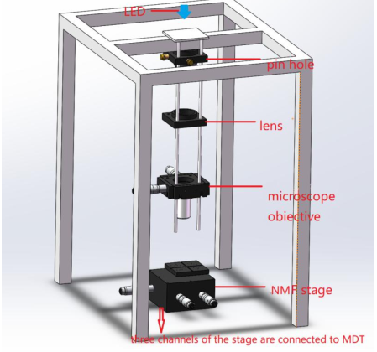

Figure structure of the optical part [3]

The LabVIEW, a program development environment is used to control the stepper motor to control the position of the shutter. G language, a graphical programming language is used in the LabVIEW,

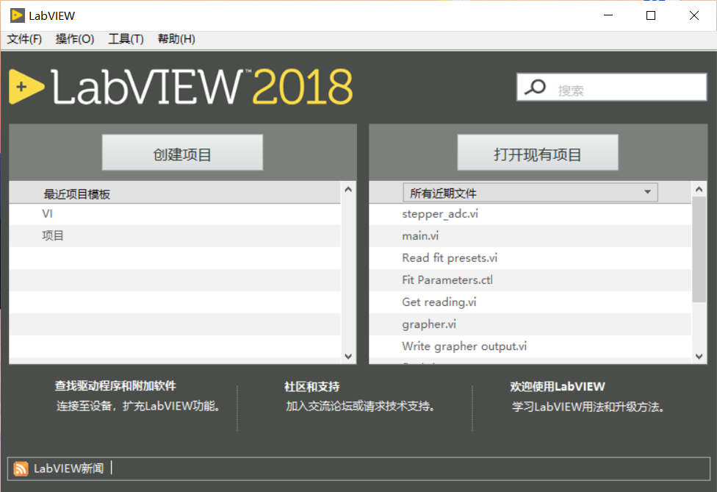

Figure LabVIEW

The whole above system is patterning in a plane, to achieve pattern in 3D, the CNC machine must be used. The sample is put on the holder, the drill is replaced by the laser. As the figure4 shows, when the user moves the axis, the laser can directly illuminate the inner ring of the sample, which realizes 3D patterning. The core problem is that how the replace the drill with a laser.

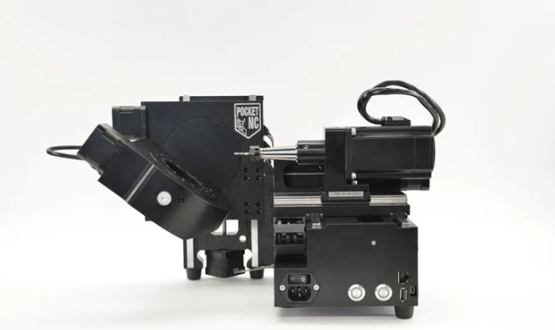

Figure Pocket 5-axis CNC

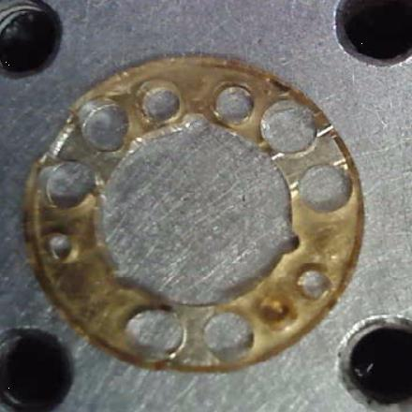

Figure the sample

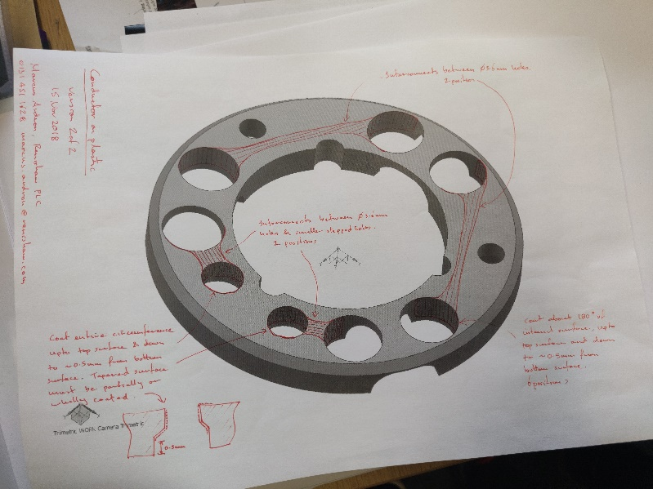

Figure Sample drawings

In the first semester, my main focus was on studying how to change the laser color. But in the second semester, As the task of the project changed, my main focus was on how to modify the CNC machine and how to use the machine.

The ultimate goal of the project is to use the designed system to pattern on the samples of polyetherimide, after subsequent chemical treatment, the metallic microtracks is presented.

# Background

This part mainly introduces the core content of some thesis materials related to the project and the software and equipment needed in the project, such as the LabVIEW and the Pocket CNC.

## 2.1 Thesis Materials

The materials are mainly the thesis provided by the supervisor. In previous experiments, the researchers have designed a complete process to produce the microcircuitry on PEI.

Micropatterning of conductive tracks on flexible substrates and contoured surfaces enables a lot of novel packaging solutions[4]. The metallization of polyimides(PI) has received much attention due to their mechanical biocompatibility, strength, resistance, chemical, and the ability to withstand high temperatures. However, using PI also has been held back because the photopatterning stage and the exposure energy must be strictly controlled. The polyetherimide (PEI) has the same excellent properties as the polyimides[1].

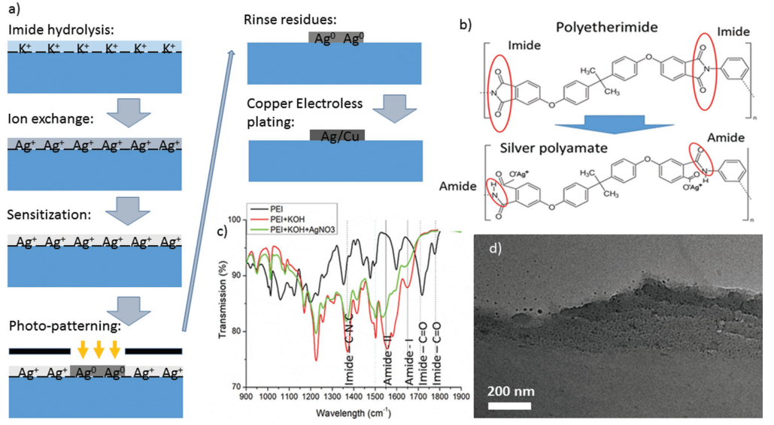

Figure The proposed process for forming silver patterns on a polyetherimide surface[1]

The specific experimental process is as follows. For different materials, some steps take different time, take filament ULTEM 9085 as example:

|  |  |  |
| --- | --- | --- |
| a | Degrease | Use the isopropanol or ethanol to clean the sample |
| b | Clean | Use DI water rinse the sample |
| c | Hydrolysis | Immerse the sample in a heated Potassium Hydroxide(KOH, 15M) solution bath at 50℃ for 15 minutes and ultrasound agitation. |
| d | Clean | Rinse it under the DI water for 2 minutes. |
| e | Ion Exchange | Place the sample in a Silver Nitrate(AgNO3, 0.1M) solution for 15 minutes. |
| f | Clean | Rinse it under the DI water for 5 second. |
| g | Optical Sensitization | Submerge the sample in Potassium Chloride(KCl, 0.01M) for 30 second. |
| h | Photoreduction | For flood exposure: photolithography mask aligner(11mW*cm-2 at 365nm)  For local exposure: high-power LED  (1W at 460nm) |
| i | Etch | Immerse the sample in ammonia(17%)to remove the metallic residues for 15 second. |
| j | Clean | Rinse it under the DI water for 2 minutes. |
| k | Etch | Etch the sample in sulfuric acid(5%) for 20 second. |
| l | Copper Plating | Electroless Copper plating |

Table Process Stage

Some chemical reagents need to be prepared on site in the chemical laboratory:

15M KOH solution recipe:

Add 84g in small quantities of 100ml of DI water with stirring.

KCl recipe:

|  |  |  |
| --- | --- | --- |
| **Concentration** | **Ethanol/DI water** | **For 80 mL stock solution** |
| 0.01M | 3:1 | 0.06g of KCl mixed into 20ml of DI water then topped up with 60ml ethanol |
| 0.1M | 1:1 | 0.6g KCl mixed into 40ml of DI water then topped up with 40ml ethanol |

Table KCl makeup

Ammonia solution:

The ammonia is in a 2.5L bottle in the solvent storage opposite the fume cupboard. It is at 35% concentration and the user can dilute it 1:1 into DI to get a 17.5% concentration.

Sulfuric acid

The user can dilute 5% sulphuric acid solution found in the acid store under the fume cupboard. 5.3 ml sulphuric acid to 94.7ml DI water.

Electroless copper bath:

6g of copper sulfate 8g of hydroxide and 28g of potassium tartrate into 200ml of DI water.

Following the process shown in Table 1 Process Stage, the user can get the processed sample:

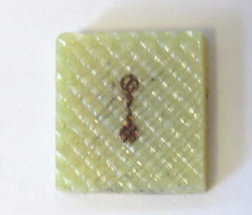

Figure Processed samples

## 2.2 Project Documentation

This part mainly contains the preparation work required for projects other than the thesis, including the introduction of the software and experiment equipment.

### 2.2.1 LabVIEW

LabVIEW is a program development environment, developed by National Instruments (NI), using C and BASIC development environments, but the significant difference between LabVIEW and other computer languages is that other computer languages use text to generate code LabVIEW uses the graphical editing language G to write programs, and the generated programs are in the form of etching[6].

The LabVIEW development environment integrates all the tools engineers and scientists need to quickly build a variety of applications, helping engineers and scientists solve problems, increase productivity, and continuously innovate[6].

The LabVIEW program is called VI (Virtual Instrument), and has the extension of .vi, so we are accustomed to use VI to represent the LabVIEW program. After the user start LabVIEW (my version is version 2018), create a blank VI, you can get two windows, one is the block diagram, and the other is the front panel, as shown below:

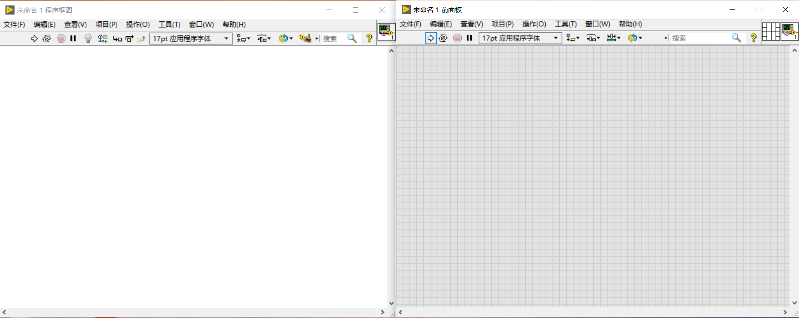

Figure Blank VI in LabVIEW

LabVIEW provides many controls that look similar to traditional instruments (such as oscilloscopes and multimeters) and can be used to easily create user interfaces. The user interface is called the front panel in LabVIEW. Using icons and wiring, we can programmatically control the objects on the front panel. This is the graphical source code, also known as G (graphics) code. The graphical source code of LabVIEW is somewhat similar to the data flow flowchart, so it is also called block diagram code. Each control on the front panel corresponds to an object in the block diagram. When data "flows" to the control, the control will display the data in a certain way according to its own characteristics, such as switches, numbers, or graphics.

In order to design the system we want, firstly add widgets in the front panel. VI front panel widgets are divided into control widgets and display widgets. The display widget is used to display data or information to the user, and the control widget is used to input data or control signals to the program. Many widgets in LabVIEW imitate real-world instrument interfaces, such as knobs, switches, and sliders. As an example, two knobs will be added to the front panel of the VI to control the amplitude and frequency of the simulated signal. When the user adds widgets on the front panel, the back panel automatically generates a block diagram. As shown below:

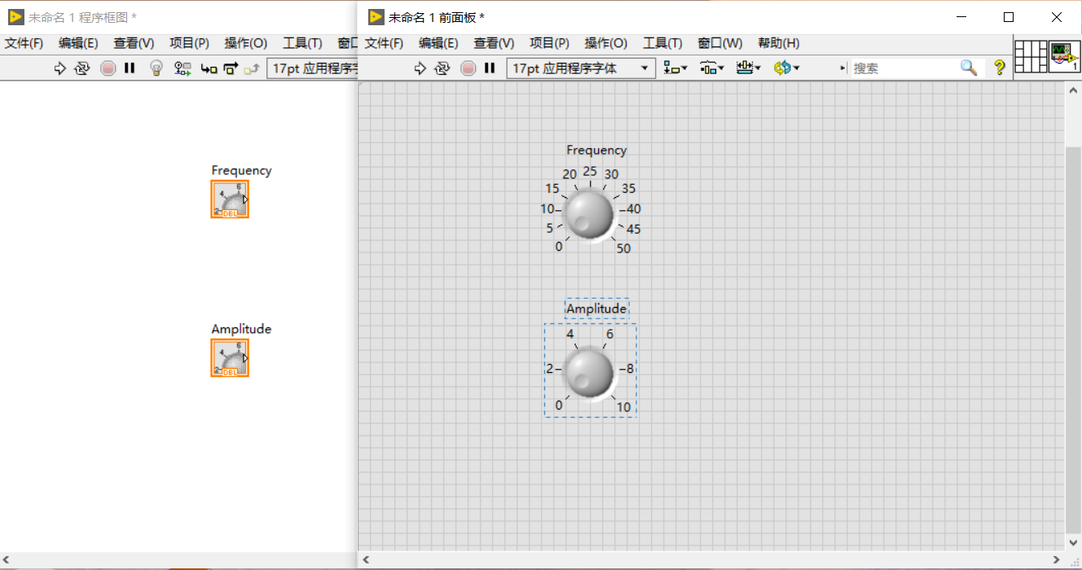

Figure Two knobs are set in LabVIEW(Frequency and Amplitude)

Next, add a signal generation module in the block diagram window, the connected signal is set to a sinusoidal signal. Enter the VI block diagram, double-click the icon of the simulation signal generation function or right-click the icon to select the Properties option. The "Configure simulation signal" dialog box shown below will pop up and set the properties:

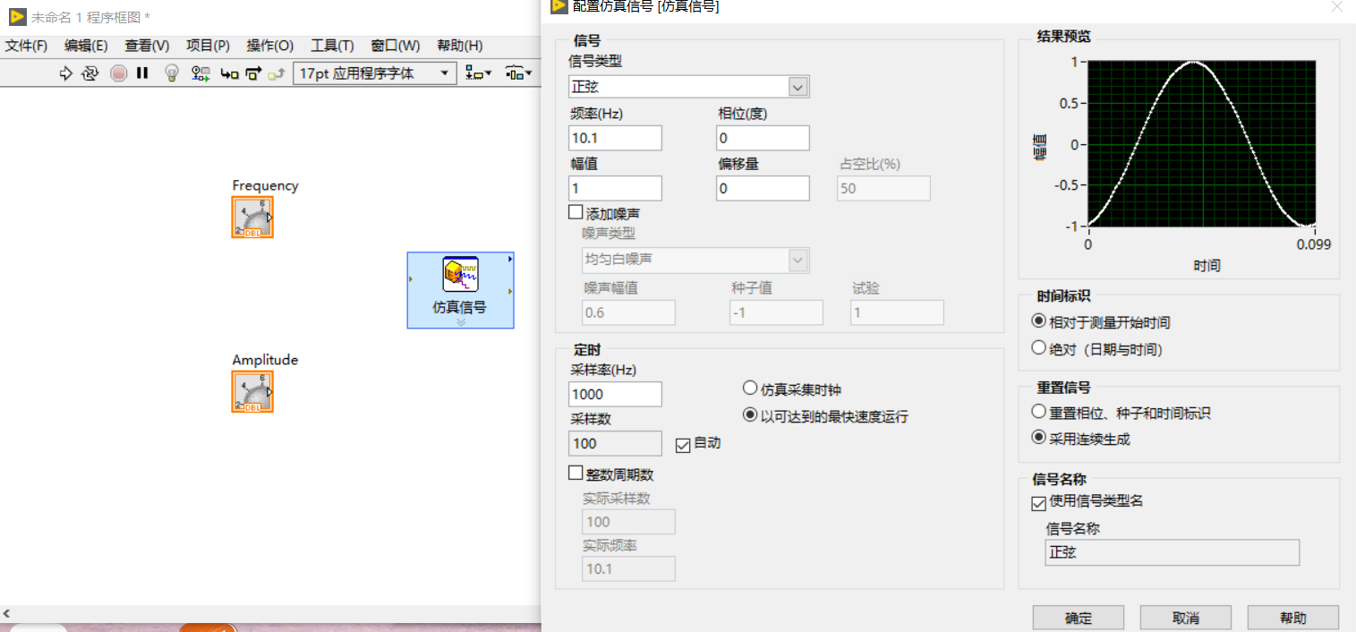

Figure Set sinusoidal Signal

Then add the oscilloscope module in the front panel, Finally, add a while loop to the block diagram. The physical structure is equivalent to the subsystem, Frame all the modules in the block diagram. as shown below:

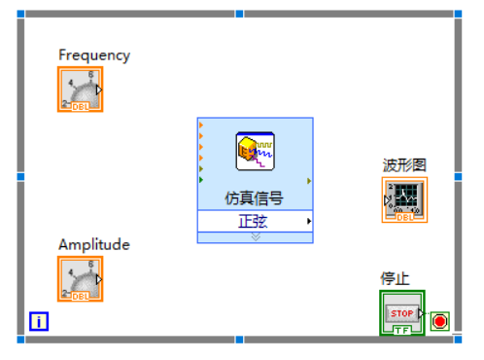

Figure Block Diagram for this small system

When all the module icons are placed correctly and the properties are set, we can connect, and If the program is edited correctly, the run button on the VI toolbar is a white arrow, which indicates that the program can be executed, otherwise it is a broken gray arrow, which indicates that the error in the program cannot be executed:

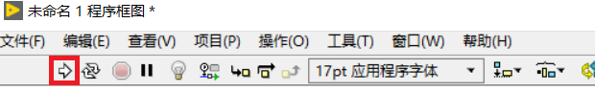

Figure The correct program

Run the program, we can change the frequency and amplitude in the front panel:

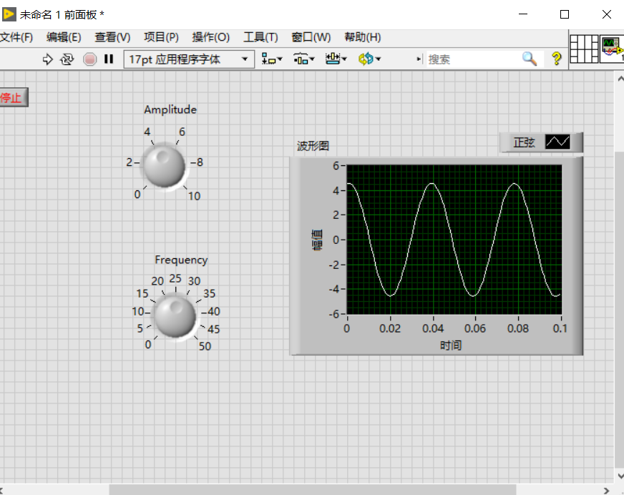

Figure Run the program

### 2.2.2 CNC machine

The CNC machine used in the project is Pocket NC V2-10. The user can control CNC through G code. Users can study the G code and the working principle of the machine through the CNC machine simulator on the network.

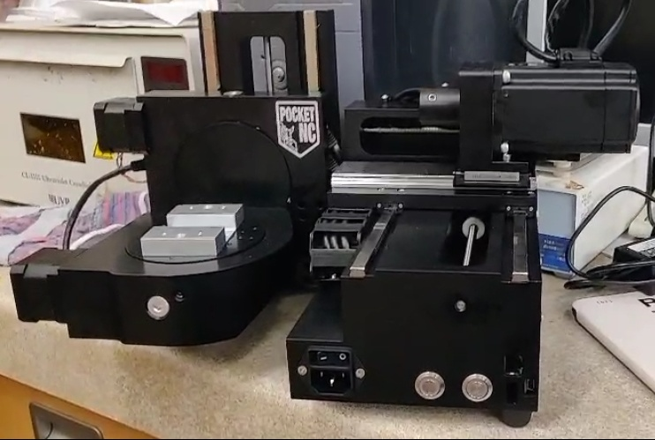

Figure The picture of CNC machine

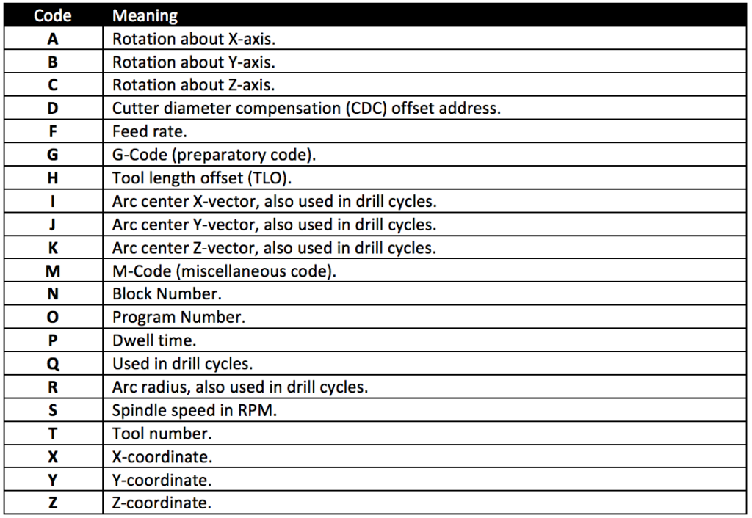

Table CNC programming language[9]

G-Code is the language used to control CNC machines. It's one type of CNC programming that CNC programmers use, the other type being CAM programming. Your machine's CNC controller probably executes g-code, although there are other possibilities--Heidenhain, Mazak, and others have proprietary formats. Some machines with proprietary formats can also run g-code. It is the Lingua Franca (working language) of CNC[7].

Here are some common codes:

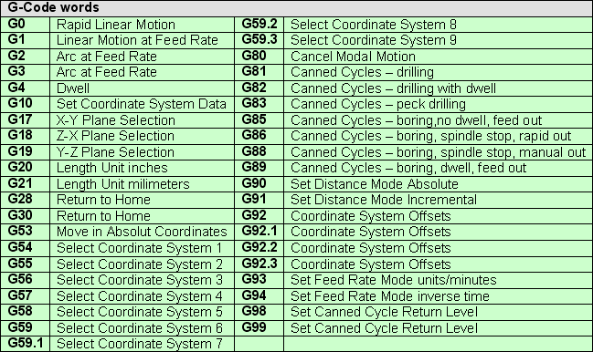

Table List of common G codes[9]

This is the demo code provided by the manufacturer, On the stage surface, the position of the drill bit can be controlled by x / y ± number:

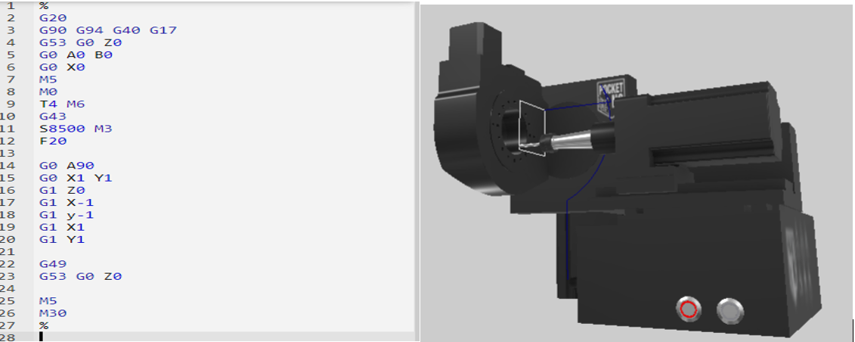

Figure Demo code and Corresponding motion state of the CNC

### 2.2.3 5-axis kinematics

Only understanding G code is not enough, the 5-axis kinematics is also very important when controlling CNC machine tools.

The processing objects of 5-axis CNC machine tools are often some parts with complex surfaces. The processing of such parts requires the direction of the tool vector to be consistent with the direction of the processing surface. In this way, the CNC machine tool should have rotational motion coordinate axes in addition to the translation coordinate axes[10].

As shown in Figure 16, the spatial motion of the CNC machine tool is composed of three translation coordinates X, Y, Z and three rotation coordinates A, B, C that rotate around the XYZ axis, respectively. According to the specific structure of the 5-axis linkage CNC machine tool, the motion coordinates X (A), Y (B), Z (C) can be realized by the translation (rotation) of the tool or the worktable that fixes the workpiece, respectively

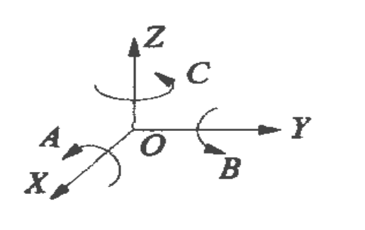

Figure Machine coordinate

5-axis linkage motion coordinates of CNC machine tools are usually composed of three translation coordinates X, Y, Z and three rotation coordinates A, B, and C. There are three situations: XYZAB, XYZBC, and XYZAC. It should be noted that the machine tool movement coordinates here are the coordinates of the tool relative to the machine tool movement coordinate system (hereinafter referred to as MCS system), not the tool's coordinates relative to the workpiece coordinate system (hereinafter referred to as WCS system)[11].

CAM/CAD systems are usually used to generate the CAM data for input to the CNC 5-axis machine as well as the CAD models of the workpiece in 3D. The tool or cutter location (CL) data, is composed of the cutter tip position and the cutter orientation relative to the workpiece coordinate system[12]. Two vectors, as generated by most CAM systems and shown in Figure 17, contain this information:

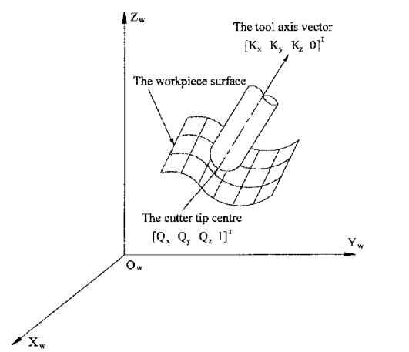

Figure Cutter location data

# Lab work

# Result analysis

Due to the impact of the coronavirus, the project had to be terminated early, and the cause of the failure of the CNC machine tool has not yet been fully determined. In this part, the cause of the failure was summarized and analyzed. Follow-up researchers can carry out the next research on this basis

## 4.0 Fault summary

CNC machine tool is a typical equipment of modern industrial automation, which should be used in precision processing and production. It is widely used. However, because CNC machine tools use advanced control technology, the maintenance of the machine tools It is also relatively complicated. The fault categories of CNC machine tools can be divided into electrical faults and mechanical faults, At the same time, these two types of faults are also related to each other. The situation is diagnosed from electrical phenomena, so that the analysis of CNC electrical faults is particularly relevant key.

## 4.1 Classification of electrical failures of CNC machine tools

There are many ways to classify the electrical faults of CNC machine tools, and they can be divided into the following categories according to the location, nature and structure of the fault.

### 4.1.1 Hardware failure and software failure

Hardware failure refers to the failure of the electrical components, CNC hardware system, wires and cables, connectors, etc. to produce an abnormal state or even damage. Hardware failures can only be eliminated by repair or even replacement. Software faults generally refer to faults caused by improper setting or incorrect modification of PLC and NC programs or parameters. Such faults often require familiarity with the system and parameters of the device, and even require reloading of the entire system parameters to initialize the system.

### 4.1.2 Inevitable failure and probabilistic failure

Inevitable faults are the phenomenon that a part of the index-controlled machine tool itself has changed, causing machine tool abnormalities. Such faults often have definite causes, and analysis and elimination are relatively easy. Probability failures are occasional failures of index-controlled machine tools. There are no certain rules to follow for failures, which are good and bad. The cause may be external influences such as electrical drift, loose grounding, or temperature changes. Abnormal, such faults are often difficult to diagnose.

### 4.1.3 System failure and peripheral failure

The system failure is a failure of the index control system itself. Of course, it may be caused by an abnormal hardware of the CNC or servo system or a problem in the software. Solving this type of failure requires the maintenance personnel to have a deep understanding of the CNC system itself. Peripheral faults refer to faults caused by electrical components other than the CNC system. Of course, the most critical thing to deal with peripheral faults is to strictly analyze and find the problem according to the electrical schematic diagram of the device.

## 4.2 Thoughts before troubleshooting

### 4.2.1 On-site understanding

The first requirement for the troubleshooting of CNC machine tools is that the maintenance personnel go to the site to listen to the operator's talk and obtain the equipment failure information as much as possible, which can reduce the scope of the machine tool maintenance.

### 4.2.2 Judging the fault category

Determine the nature of the fault by understanding with the operator, after fully understanding the possible range of the fault, the maintenance personnel can determine the nature and type of the fault, for example, it can be determined whether it is a software or hardware problem, whether it is the CNC system itself or a peripheral fault, inevitability or probability Faults, etc., the basic categories can be quickly judged by those who are often engaged in CNC machine tool maintenance.

### 4.2.3 According to the nature of the fault

Develop maintenance methods from the most probable cause. When the general nature of the CNC machine tool is clear, the maintenance direction can be worked out. For example, peripheral faults need to refer to the electrical schematic diagram of the device. For system faults, you need to check the CNC system manual and parameter table. , Probability failure requires repeated observation and determination.

## 4.3 Fault finding method

There are many ways to find the cause of the failure, here are some commonly used inspection methods, the check methods should be used in turn.

### 4.3.1 Check appearance

(1) Look

Check the general situation from the appearance of the device, including checking the electrical cabinet of the device to see if there is a switch trip, whether there is a component burnout, etc.

(2) Listen

If it is a fault in the operation of the device, you can listen to whether there is abnormal noise in any part of the device, so as to lock the source of the fault.

(3) Smell

The components of the electrical cabinet can be quickly judged by smelling under certain short circuit conditions.

(4) Touching Touch the outside of these components when the CNC system unit, servo drive unit fails or the motor fails, and feel whether the temperature has increased significantly can also help the team to shorten the time to find the fault.

### 4.3.2 Multimeter testing

In the case of peripheral faults, the most common way to find is to analyze the possible fault parts according to the electrical schematic diagram of the device, and then use the multimeter circuit, of course, you can use the power failure test or the point test to determine the fault.

### 4.3.3 Search by alarm

CNC machine tools have a set of diagnostic software. Once the equipment fails, there are prompts for the failure. When a failure occurs, it is convenient for the maintenance personnel to narrow the scope of investigation. However, the diagnosis of any CNC system has limitations in use, so maintenance personnel cannot rely too much on the diagnosis system at any time, and the alarm can only be a reference method for maintenance personnel.

### 4.3.4 Parameter adjustment and initialization

The CNC system is often stopped due to disordered parameters or the operator accidentally changed the CNC parameters when entering the processing program, or the equipment is running abnormally. Therefore, when a software failure occurs, the parameters that may cause failure should be carefully tested The maintenance personnel are required to be quite familiar with the software parameters, and if necessary, they can also initialize from the new device CNC and servo CNC.

### 4.3.5 Try to replace new spare parts

After using the instrument to find the fault according to the electrical schematic diagram, that is, after determining the damaged or malfunctioning component, you should replace the new spare parts in time. Of course, you can’t think that all problems can be solved by replacing the spare parts. There are also many problems in this regard. For example, many components such as servo drives, inverters, etc. need to be modified after replacement, and CNC replacement also requires parameter initialization. These are skills that maintenance personnel must master. However, when the researcher is not 100% sure that the CNC can be repaired by replacing , you can directly contact the manufacturer, the Pocket CNC Ltd: [info@pocketnc.com](mailto:info@pocketnc.com)

# Reference

1. J. Marques-Hueso *et al.*, “Flexible Electronics: A Rapid Photopatterning Method for Selective Plating of 2D and 3D Microcircuitry on Polyetherimide (Adv. Funct. Mater. 6/2018).,” *Advanced Functional Materials*, vol. 28, no. 6, 2018.
2. J. Marques-Hueso, Printed electronics on flexible substrates 2018 (Not published)
3. Xin Wang, Setup for a small area and high accuracy printing for flexible electronics.2019(Not Published)
4. A. Nathan *et al.*, “Flexible Electronics: The Next Ubiquitous Platform,” *Proceedings of the IEEE*, vol. 100, no. Special Centennial Issue, pp. 1486–1517, 2012.
5. Zhuang Ruirong and Wu Xianqiu, “Stepper Motor Control Based on LabVIEW” *Modern Electronics Technique,* vol.4, 2012.(in Chinese)
6. What is the LabVIEW; (in Chinese), Last accessed time: 2020-04-09

<https://baike.baidu.com/item/LabVIEW/4165214?fr=aladdin>

1. CNC Cookbook G code Course, Last accessed time: 2020-04-02 <https://www.cnccookbook.com/cnc-programming-g-code/>
2. Chien-Yu Lin and Ching-Hung Lee, “Remote Servo Tuning System for Multi-Axis CNC Machine Tools Using a Virtual Machine Tool Approach,” *Applied Sciences*, vol. 7, no. 8, 2017.
3. G code; Last accessed time: 2020-04-20

<https://www.google.com/search?q=G+CODE&oq=G+&aqs=chrome.0.69i59j69i57j69i60l6.4652j0j7&sourceid=chrome&ie=UTF-8>

1. C. Xie, W. . Zhang, and X. . He, “Kinematic analysis and post-processing algorithm research for 5-axis CNC machine tools with a universal head,” in *2009 IEEE International Conference on Industrial Engineering and Engineering Management*, 2009, pp. 2309–2313.
2. Chih-Ching Lo. “Real-time generation and control of cutter path for 5-axis CNC machining[ J]” .*International Journal of Machine Tools &Manufacture,* 1999( 39) :471-488
3. 5-Axis Kinematics; Last accessed tome: 2020-04-04

<https://linuxcnc.org/docs/ja/html/motion/5-axis-kinematics.html>

1. RJ du Preez. “3D 6-DOF Serial Arm Robot Kinematics” SA-CNC-CLUB, Dec. 5, 2013.

# Bibliography

[1] CNC machine tool fault diagnosis technology; Wang Guicheng; Chemical Industry Press (CIP); 2010-3; ISBN: 9787122050410

[2] LabVIEW Introduction and Practical Development: 100 cases; Dou Xingming, Tian Jingjing, Xia Ning; Electronic Industry Publishing House; 2011-3;ISBN:9787121129988

# Minutes

|  |  |
| --- | --- |
| **Project Minutes 1** | |
| **Date** | 23/09/2019 |
| **Present** | Jose Marques Hueso  Yibing Liu  Yuze Sun  Wei Jiang |
| **Action** | • Discussing the direction of research.  • Talking about the related thesis and the materials used in FDM 3D-printing. |
| **Plan** | • Read these two papers and the other materials carefully.  • Write a brief conclusion about the main method and target of these researches.  • determine the research direction |
| **Recorder** | Yibing Liu |
| **Signature** |  |

|  |  |
| --- | --- |
| **Project Minutes 2** | |
| **Date** | 30/09/2019 |
| **Present** | Jose Marques Hueso  Yibing Liu  Yuze Sun  Wei Jiang |
| **Action** | • Talking about the assignment of our task.  • Discussing the work we need to do for each. |
| **Plan** | • Read the following paper and have a deeper understanding of various materials an d their polymers.  • Learn how to use the LabVIEW and learn the G language |
| **Recorder** | Yibing Liu |
| **Signature** |  |

|  |  |
| --- | --- |
| **Project Minutes 3** | |
| **Date** | 11/10/2019 |
| **Present** | Jose Marques Hueso  Yibing Liu  Yuze Sun  Wei Jiang |
| **Action** | • Discussing the problems we met in the design progress with supervisor. |
| **Plan** | • Read the LabVIEW file and understand the serial-port communication between devices.  • Keep on reading materials and conduct experiments in the lab. |
| **Recorder** | Yibing Liu |
| **Signature** |  |

|  |  |
| --- | --- |
| **Project Minutes 4** | |
| **Date** | 19/10/2019 |
| **Present** | Jose Marques Hueso  Yibing Liu  Yuze Sun  Wei Jiang |
| **Action** | * Testing the possibility of moving sample to the center of platform |
| **Plan** | * Try to modify the code of software to improve the accuracy and let the patterning process can be successful. * Try to assemble the colour selecting system. |
| **Recorder** | Yibing Liu |
| **Signature** |  |

|  |  |
| --- | --- |
| **Project Minutes 5** | |
| **Date** | 26/10/2019 |
| **Present** | Jose Marques Hueso  Yibing Liu  Yuze Sun  Wei Jiang |
| **Action** | • Do a short presentation about Yuze’s aim and plan for this project.  and discuss some details I met in the process of test.  • make sure that I will have a CNC machine, I need to try to learn the CNC. |
| **Plan** | • Keep test the devices, letting Laser can be work and letting the software can have a better accuracy.  • begin to read some material about the CNC machine |
| **Recorder** | Yibing Liu |
| **Signature** |  |

|  |  |
| --- | --- |
| **Project Minutes 6** | |
| **Date** | 01/11/2019 |
| **Present** | Jose Marques Hueso  Yibing Liu  Yuze Sun  Wei Jiang |
| **Action** | • Give a short feedback about the presentation last week.  • Talk about the 3-point positioning method. |
| **Plan** | • read more literature about the manufacturing method.  • use the simulator to understand the running of the CNC |
| **Recorder** | Yibing Liu |
| **Signature** |  |

|  |  |
| --- | --- |
| **Project Minutes 7** | |
| **Date** | 08/11/2019 |
| **Present** | Jose Marques Hueso  Yibing Liu  Yuze Sun  Wei Jiang |
| **Action** | • Discuss some problems about the maximum voltage and how to gather the light from the glass.  • We can write a brief ask to apply for grilling machine and a device to change the output current to suit the maximum voltage |
| **Plan** | • Write down our needs in detail, modify the code to let the motor can stop at every time.  • Collect some online teaching videos about the CNC |
| **Recorder** | Yibing Liu |
| **Signature** |  |

|  |  |
| --- | --- |
| **Project Minutes 8** | |
| **Date** | 22/11/2019 |
| **Present** | Jose Marques Hueso  Yibing Liu  Yuze Sun  Wei Jiang |
| **Action** | • Talk about the position where we need to place the camera and laser.  • Discuss the transistor circuit and know some officers responsible for mechanical workshop and laser cutting.  • Discuss that there is not enough space to put the color selecting system |
| **Plan** | • Try to understand the G code and learn to write G code to control the CNC |
| **Recorder** | Yibing Liu |
| **Signature** |  |

|  |  |
| --- | --- |
| **Project Minutes 9** | |
| **Date** | 29/11/2019 |
| **Present** | Jose Marques Hueso  Yibing Liu  Yuze Sun  Wei Jiang |
| **Action** | • Know the material of all the circuit and antenna I need to print on PEI.  • The diode laser seems to have some problems, so Yuze need to describe the issues with the supervisor.  • The machine is not yet sure when it will be delivered to the school |
| **Plan** | • Solve the software error in the laboratory computer and improve the circuit, letting it work as brightly as possible.  • The machine is not sure when it will arrive, so continue to study the color selection system, which means continue to learn the LabVIEW. |
| **Recorder** | Yibing Liu |
| **Signature** |  |

|  |  |
| --- | --- |
| **Project Minutes 10** | |
| **Date** | 06/12/2019 |
| **Present** | Jose Marques Hueso  Yibing Liu  Yuze Sun  Wei Jiang |
| **Action** | • The date that the mechanical work can be done.  • Discuss some problems about the diode laser, as it cannot work as perfectly as directly connect to the +5V and GND. |
| **Plan** | • Buy an external power supply that can provide enough current for the laser.  • Reading more paper about the chemical component and manufacturing method in the part 2, preparing for work of next semester. |
| **Recorder** | Yibing Liu |
| **Signature** |  |

|  |  |
| --- | --- |
| **Project Minutes 11** | |
| **Date** | 01/02/2020 |
| **Present** | Jose Marques Hueso  Yibing Liu  Yuze Sun  Wei Jiang |
| **Action** | * First meeting of the second semester, Confirmed Yuze’s next job, continue to find the way to laser printing. Find the best speed for laser writing on the sample. * Adjusted my task, make sure that there will be 5-axis CNC machine, no longer doing the wavelength part work.   My task has been updated   * Learn to control the CNC machine. * Find the way to control laser on and off using G code. * Replace the drill by the laser and use the whole system to laser printing in 3D on the sample. |
| **Plan** | In the next week, I continue to get familiar to the G code and teat the G code in online simulator. |
| **Recorder** | Yibing Liu |
| **Signature** |  |

|  |  |
| --- | --- |
| **Project Minutes 12** | |
| **Date** | 14/02/2020 |
| **Present** | Jose Marques Hueso  Yibing Liu |
| **Action** | **Completed actions**   * Getting familiar to the software Fusion 360. * Have a basic understanding of G code. * Run the G program in the online simulator * Can control the movement of every axis of the CNC machine.   **Problems**   * There is vibration during machine movement, but the sample is very small, which means that the laser can’t write accurately. * There is no external output on the lathe, I haven’t found the way yet to use G code control the laser on. |
| **Plan** | * There is small problem when the CNC machine run a run a complete G program, I will solve it in next week. * Read more to find a way to control the laser by G code. * Try to reduce machine jitter when it is working. |
| **Recorder** | Yibing Liu |
| **Signature** |  |

|  |  |
| --- | --- |
| **Project Minutes 13** | |
| **Date** | 11/03/2020 |
| **Present** | Jose Marques Hueso  Yibing Liu  Yuze Sun  Senpu Yuan  Abdulrhman, Mansour |
| **Action** | • Discuss some reason for why there is no pattern on the PEI surface with laser.  • the CNC has arrived, and I begin to use it |
| **Plan** | • Use new KOH solutions to do chemical treatment again.  • Find methods like grayscale histogram, optical contrast to quantify the patterning results.  • Try to find the way to replace the drill by the laser.  • Contact the machine manufacturer for more information |
| **Recorder** | Yibing Liu |
| **Signature** |  |

|  |  |
| --- | --- |
| **Project Minutes 14** | |
| **Date** | 17/03/2020 |
| **Present** | Jose Marques Hueso  Yibing Liu  Abdulrhman, Mansour |
| **Action** | • Discuss the problem I met in transferring the machine.  • Request to continue to use the laboratory to complete the project.  • Due to the impact of the new coronavirus, the project must end early. |
| **Plan** | • The last modification test for the machine  • Summarize the problem and report it to the professor |
| **Recorder** | Yibing Liu |
| **Signature** |  |